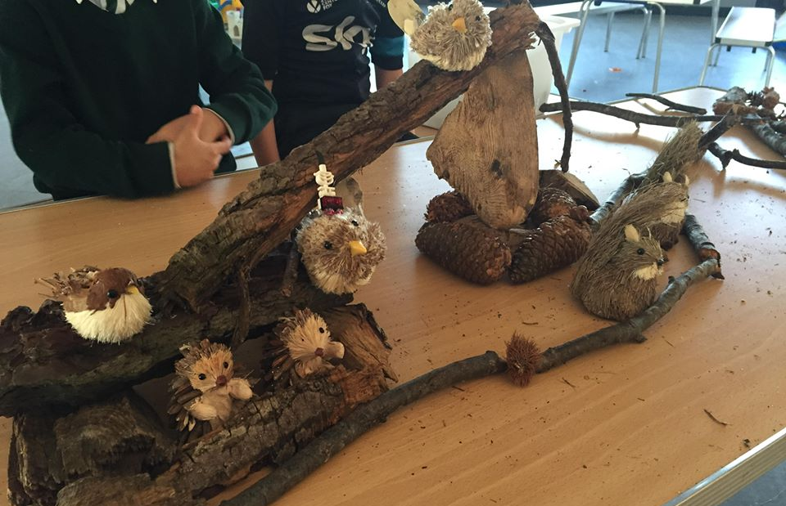
How we deliver the EYFS in a Covid Secure Way, and Still Manage to PLAY!

As an after school club we recognise that children have spent all day in a possibly tiring learning environment and as such we aim to provide them with a variety of play opportunities. Under the EYFS, we no longer need to formally support the children’s learning and development goals as identified by Ofsted but in order to minimize transmission of the virus we have had to organize ourselves differently.

For children play is a crucial part of learning and healthy development, during the pandemic many children will have been adversely affected, so we have been working hard to ensure a play environment that they will recognize and keep them safe.

- While the children will be in Year Group Bubbles they will also have the benefit of more consistent adults. This will allow us to ensure that the resources children particularly enjoy will be out when they attend and which will be cleaned before and after the session. We will be holding back many of our toys and resources to minimize transmission.

- We will still provide a range of planned and free play activities, a range of adult led STEM, art and craft activities as well as the option to self-select their own arty resources with a few more limitations than usual.

- Children will be able to play together, although we will discourage very close play indoors.

- We will be developing our outdoor play and spending more time outdoors weather permitting.

- We usually ask the children what they want in our Children’s Meetings and Questionnaires- this covers activities, toys and games as well as snack ideas (as long as they meet our Healthy Eating guidelines!) and we will continue to do so.
- We will continue to make a variety of play available- baking and healthy cooking activities, more role play activities- such as a Home Corner kitchen, a Post Office, an Ice Cream Parlour or a Bank, planting and growing activities, etc. Please see your Keyworker or Club Manager for more information.

Some play will have to be adapted – play dough, for example, if used will be individual portions (which the children like anyway!) but then either taken home or thrown away instead of being re-used. We can however substitute this sensory play with ‘orbees’ as they can be washed at the end of the session. We are looking carefully at each game, craft, activity and play to assess the risk it carries and make the appropriate adaptations.

For more details about how we are managing the risk of transmission, please see the Risk Assessment for each of our settings on our website (will be published before September 2020)

Finally, we will, as always, provide time and space for the children to relax if they should choose, recognising that sometimes, children need a break from all the activity too!

